Lab: Remote code execution via web shell upload

Open the burpsuite and turn on the intercept in the proxy. Login with the given credentials and upload a picture. Now forward the uploaded request to repeater and modify the request as shown in second image. Also forward the get method request of the uploaded image and modify it for the script. Now send both the modified request and the secret will be displayed.

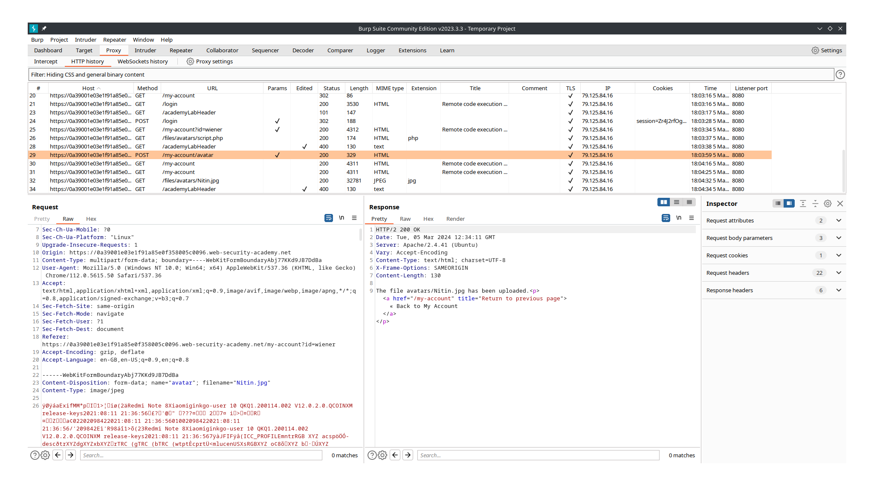

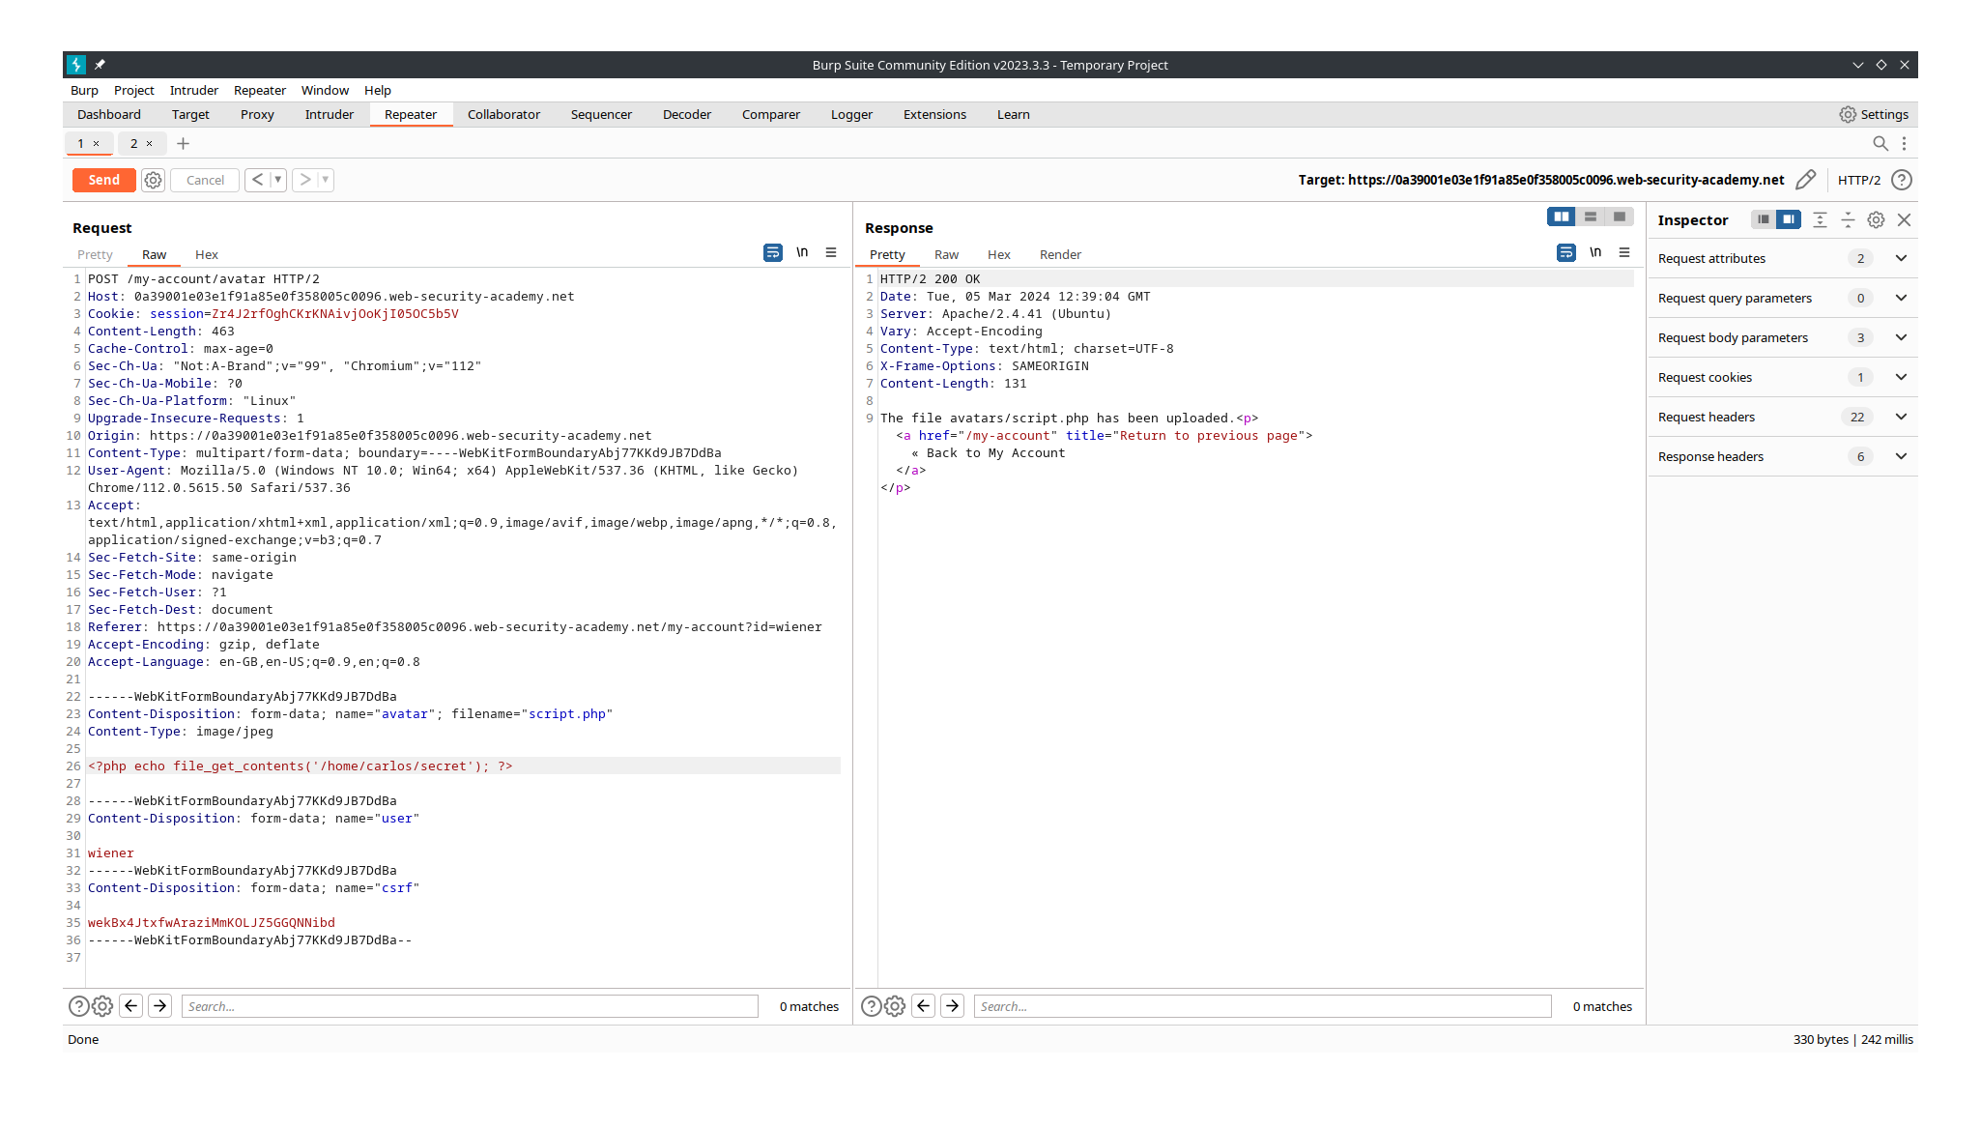

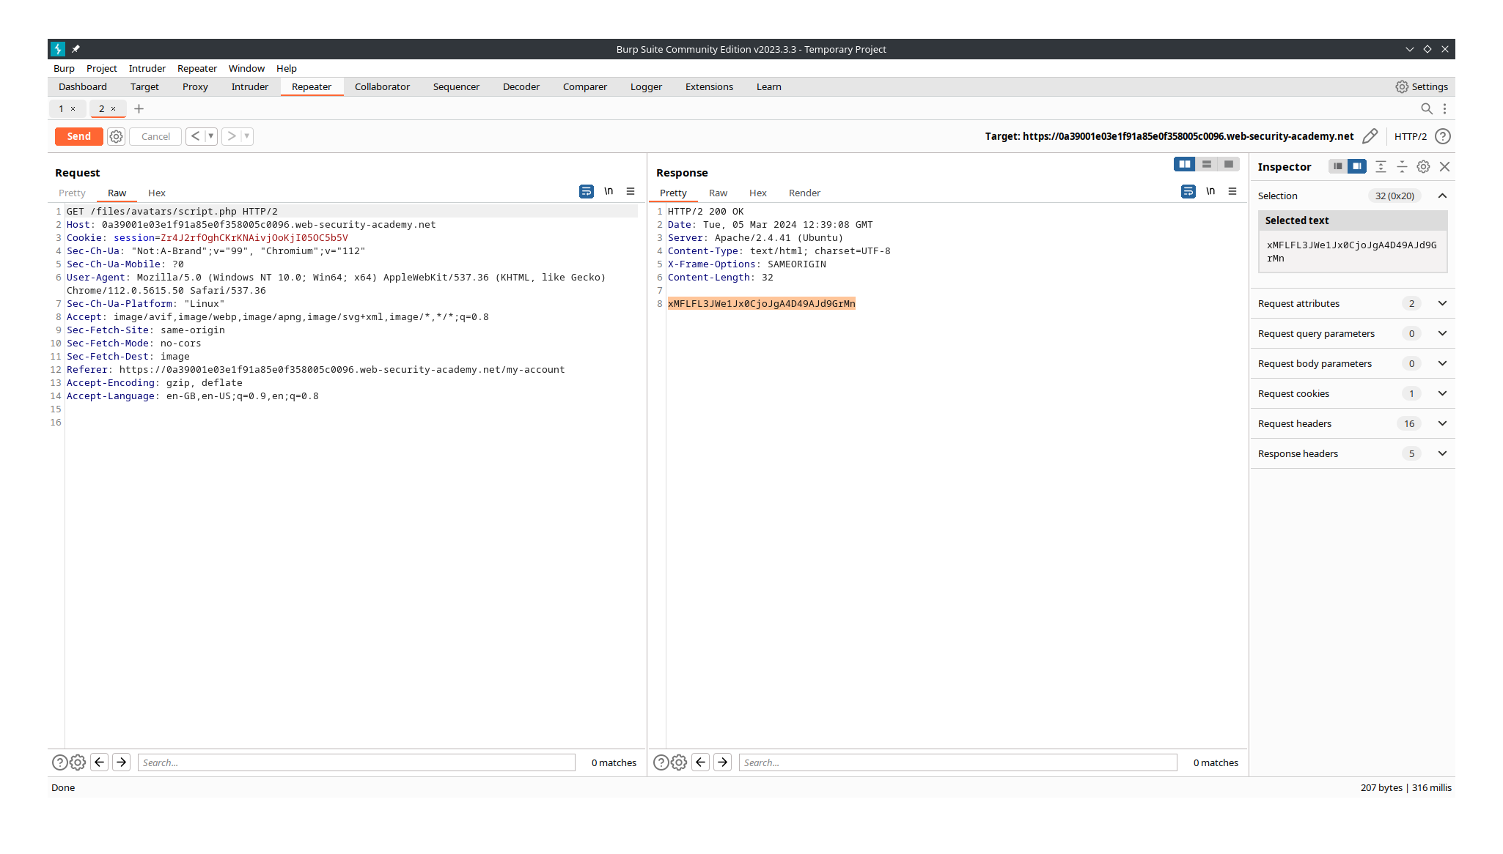

Lab: Web shell upload via Content-Type restriction bypass

